Group Project – Interim Group Report

Client: Dr F C Langbein

Product

Owner: C Allen

Team 1: R Watson

A Lamnea

W Cooter

S Tomlinson

Team 2: Ellis Doran

E Joiner

H Nicholson

J Davies

Back End: Ethan Kelly

Group 10 was broken into three primary work groups. Team 1 and team 2. I broke it down like this so that the work could be shared out with more structure. This allowed the authority to be shared too by having two team leads. I felt this was the best approach initially as it allowed the task to be broken down into a series of manageable tasks which could be concurrently developed.

Following our initial meeting with the client we a number of requirements that we broke into functional and non-functional requirements.

|  |  |
| --- | --- |
| Functional | Non-functional |
| Upload projects[1] | Flexible on group members |
| Assign students to groups | Must function on minimum input |
| Manually add/remove students | Must be easy to add to |
| Provide mark moderation | Must present a username |
| Must ensure simultaneous release of marks | Allow for pseudo-random assignment to groups |
| Enforced mark deadlines |  |
| Give students tools to manage projects |  |
| Must include tools to help students complete group project |  |

In order to meet these criteria, we broke the system into 4 major parts which should work together to various degrees in order to successfully meet all requirements. These are a file upload system, a grouping tool, project tools and a grading tool.

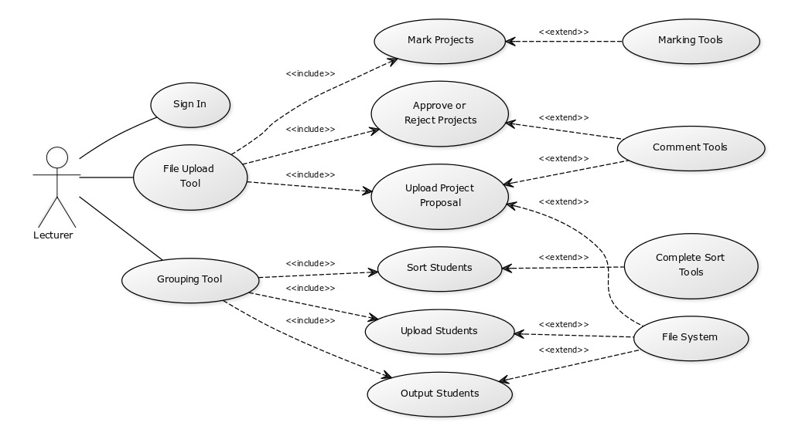

*fig 1. The final goal should look something like above for a lecturer*

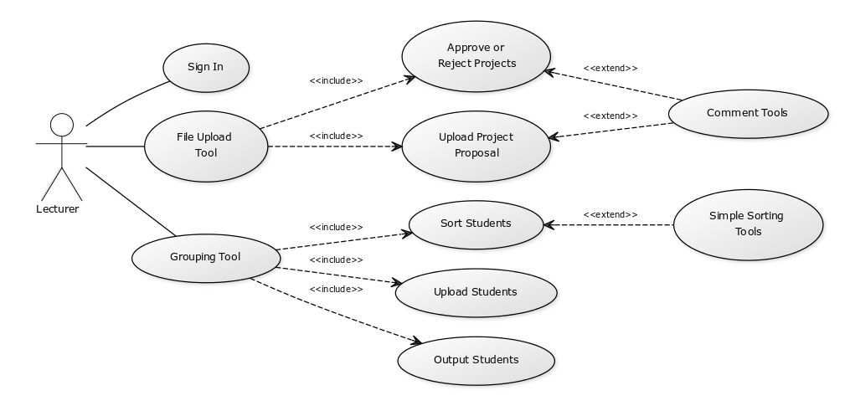

*fig 2. The project currently looks like above*

Currently the project has been developed from the clients’ side, this is because the client side appears to be the most work, in terms of wider tool implementation. Future issues to be addressed will be the implementation of the file system into the upload tool, the implementation of marking tools for the lecturer and the student, student reporting and project tools. These will be approached during the next development cycle.

From the current development cycles events, I expect the next best area of development focus should be to finish the file system implementation. Also, to work on the marking and student elements, this should allow several parts to come together quickly. Completing the framework for these parts should make the project more complete in terms of usability and should allow the initial set of user requirements to be fulfilled. Moving on from there would be a focus on improving features, removing bugs and finishing any last user requirements.

The client had concerns over the security of the system in place during this development cycle, the issue was related to usernames and passwords being stored on the users’ browser without salting or hashing. Those concerns should be met with the implementation of the database system with salting and hashing of passwords present in the database plans. This new security focused design should assure any concerns over user details and their security.

During the early phases of this project the main focus was creating a tool to meet client specifications. In order to form something of substance both teams were assigned a part of the project to focus on, this allowed the people who would be implementing it to have an input. The result was a file upload tool using a web interface to host files for potential projects and completed projects.

The groups then focused on improving the tools until they were at a standard for the client to use in the capacity outlined by the client during the first meeting. Following two weeks of development the client was shown the project again and asked for input.

*Plan:*

*~~UML of system in broad~~*

*~~Talk about how this matches clients requests~~*

*~~Talk about issues it has caused~~*

*Talk about milestones being planned from 4 parts of system and tem delivered manageable sprints early on to assure work turn-out*

*Demonstrate progress towards solution*

*Identify how to solve issues that have been encountered*

*Risk assessment*

*Legal/social/ethical*

We started development of the file upload system to begin with, this allowed us to produce a core system, which could be added to later in order to allow mark moderation and a grouping tool together. The file upload system was given to team 1 in order to provide a working foundation for all the code we would produce.

To guide Team 1 through the development process I generated some testable requirements to meet throughout the design. These were developed from the requirements given by the client and from issues we identified in the planning process.

To speed up development it was my choice to develop a python script to produce a list of students that are formed into groups. This allowed the development of the most important and the hardest to implement tools first. Following these two tools development my plan was to present to the client the option to have both of these tools separately working or whether to integrate them.

Team 1

[Delete everything between square brackets when done, these are a content guide and should help the report follow the same themes require for your part of the report]

[Short intro:

-Requirements

-How you expected to meet them]

[2-4 para

-How you planned your data structure use (why you used array instead of map or w/e)

-Talk about cohesive code design

-Talk about how it is coupled with other elements of the program

-Explain how it solved the problem]

[UML of your part of the system (speak to Chloe if you need help)]

[3-5 paragraphs

-Explain how the testable criteria was met

-Explain issues you have encountered

-Talk about how you think these issues could be solved

-Explain the current status of the program and the next step]

[Summary

-Explain why the structure of your program is the best within the requirements

-Talk about team level decisions you would redo]

Team 2

[Short intro:

-Requirements

-How you expected to meet them]

[2-4 para

-How you planned your data structure use (why you used array instead of map or w/e)

-Talk about cohesive code design

-Talk about how it is coupled with other elements of the program

-Explain how it solved the problem]

[UML of your part of the system (speak to Chloe if you need help)]

[3-5 paragraphs

-Explain how the testable criteria was met

-Explain issues you have encountered

-Talk about how you think these issues could be solved]

[Summary

-Explain why the structure of your program is the best within the requirements

-Talk about team level decisions you would redo]

Back-End

[Short intro:

-Requirements

-How you expected to meet them]

[2-4 para

-How you planned your data structure use (why you used array instead of map or w/e)

-Talk about cohesive code design

-Talk about how it is coupled with other elements of the program

-Explain how it solved the problem]

[UML of your part of the system (speak to Chloe if you need help)]

[3-5 paragraphs

-Explain how the testable criteria was met

-Explain issues you have encountered

-Talk about how you think these issues could be solved]

[Summary

-Explain why the structure of your program is the best within the requirements

-Talk about team level decisions you would redo]

1. Upload of project proposals and students finished projects.